Aipaxe Connections to Aiptek Camera
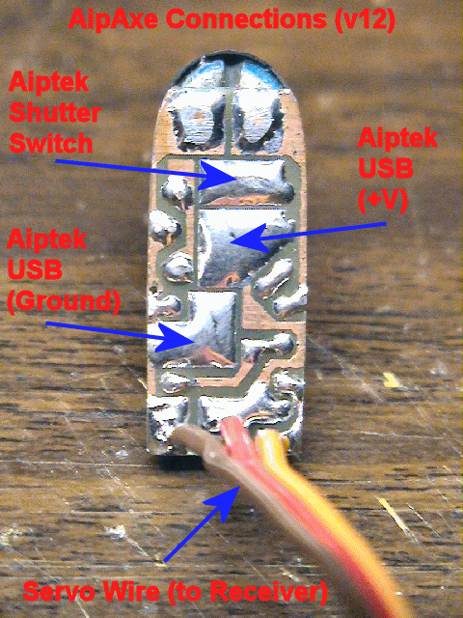

More info @ www.diyrc.com

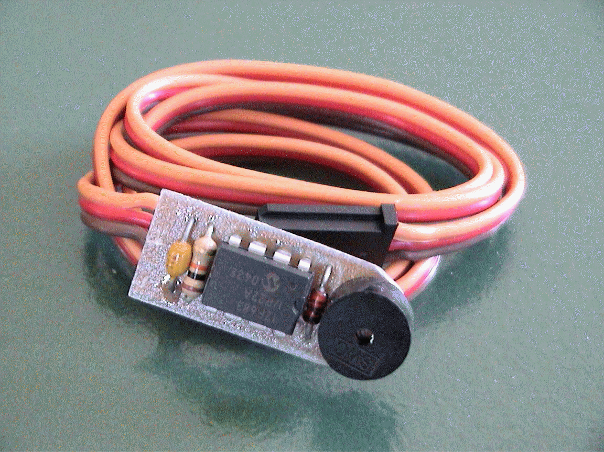
“AipAxe” R/C Switch
Operating Instructions
(THIS IS FOR THE NEWER FIRMWARE)
1. With both the transmitter and receiver powered off, plug the camera's servo plug into the receiver channel # to which you want to use as your shutter control. This can either be a switch or joystick.
2. Power up the transmitter first and position the switch or stick (corresponding to channel on receiver which switch is connected) in the direction to which you would want to be the OFF position (the position where no picture is taken).
3. Now power up the receiver and you will hear the switch and Aiptek camera eventually power up (beeps). About a second or two after that (as the circuit analyzes the receiver servo signal), you will hear a "Ready" beep (2 low beeps then a longer high beep) indicating that the circuit is ready for operation (no others beeps should be heard until you take a picture).
IS THAT SIMPLE?
4. To take a picture, move the joystick/switch to the ON position and then return it to the opposite (OFF) position. You should hear the switch circuit output a low to high chirp, and then quickly hear the Aiptek camera take a picture (also visible on the Aiptek display). If the transmitter's switch/joystick is left in the ON position, the switch circuit will make the Aiptek camera take a picture approximately every 7 seconds, until the switch/joystick is returned to the OFF position.
5. If you were to turn off the transmitter while the receiver and camera are powered up, the switch circuit will eventually continually beep, indicating that there exists no servo signal. This is the built-in "Model-Finder" alarm that will hopefully help you locate a downed aircraft. Just power off the transmitter and the circuit will begin to beep.
6. Upon powering up the transmitter, you will eventually hear a "Ready" beep (2 low beeps then a longer high beep) indicating that the circuit is ready for operation once again.

(THIS IS FOR THE OLDER FIRMWARE)
1. With both the transmitter and receiver powered off, plug the camera's servo plug into the receiver channel # to which you want to use as your shutter control. This can either be a switch or joystick.
2. Power up the receiver and you will hear the Aiptek camera eventually power up (beeps). A few seconds later, you will hear the camera switch circuit power up (beeps). The circuit will then continually beep, indicating that there exists no servo signal, since the transmitter is off. This is the built-in "Model-Finder" alarm that will hopefully help you locate a downed aircraft. Just power off the transmitter and the circuit will begin to beep.
3. After the camera and switch has powered up, (with transmitter still powered OFF) position the transmitter's switch or joystick (the control corresponding to the channel # you have the camera plugged into) such that it is in the ON position, that is, the position you want in order to take a picture.
4. After this trigger position is set on the transmitter, power on the transmitter and you should hear 2 high beeps from switch circuit. Following these beeps, you should then hear a low beep every 2 second or so. This is indicating that it is waiting for you to arm the camera switch. You do this by positioning the switch/joystick to the OFF position (the position for which the camera will cease taking pictures). Upon repositioning the switch/joystick, you will hear a "Ready" beep (2 low beeps then a longer high beep) indicating that the circuit is ready for operation (no others beeps should be heard until you take a picture).
5. To take a picture, move the joystick/switch to the ON position and then return it to the opposite (OFF) position. You should hear the switch circuit output a low to high chirp, and then quickly hear the Aiptek camera take a picture (also visible on the Aiptek display). If the transmitter's switch/joystick is left in the ON position, the switch circuit will make the Aiptek camera take a picture approximately every 7 seconds, until the switch/joystick is returned to the OFF position.

Additional Notes
- The circuit saves the last user-programmed settings (trigger point and trigger direction) for use next time you power it up. In order for the circuit to use these saved settings, you MUST power up the transmitter before powering up the camera and receiver. If you do not, you will have to reprogram the settings, which only takes 5 seconds the most.
- Aiptek cameras can be funny in that some are particularly sensitive to input voltage. Most Aiptek cameras I have modified work fine on 5V and even 5.5 volts. If you try to power up the camera from the receiver and the receiver is powered using 5 cells (6 volts), the camera will probably not turn on, and you in fact might damage the PIC switch circuit. Some work, some don’t. It is highly recommended that you power up the receiver/camera using either a 4 cell battery pack (4.8-5.2 volts) or use a Battery Elimination Circuit (BEC) or voltage regulator that outputs a regulated 5 volts.
- When you connect the camera up to your computer to download pictures (via USB cable), the camera and switch circuit are powered up. Because the switch circuit senses NO servo signal, the model-finder alarm will beep continuously as you are downloading pictures. The download process is not affected by this beeping. Once the downloading is complete, simply unplug the USB cable from the camera.
- This mod originally was designed such that the camera could still be powered and operated with two AAA batteries. After modifying a bunch of these cameras, I have noticed that some work normally with batteries installed but some do not. I therefore can not guarantee that the camera will operate properly with batteries installed. The intention of this modification was to make an R/C controlled aerial camera using a miniature hand-help digital camera. I can guarantee that this mod will do just that!
- There has been rare occurrences where an Aiptek camera can simply go "berserk"...., i.e. continual beeping or just does not work at all (indicated some times by all "eights" (888) in the camera display). In this case, it is good to reset the camera by hold down the "mode" and "shutter" buttons simultaneously for several seconds until a beep is heard (do this while camera is powered up). Removing power for a few seconds and reapplying has some times fixed the problem too.

